CUSTOMER

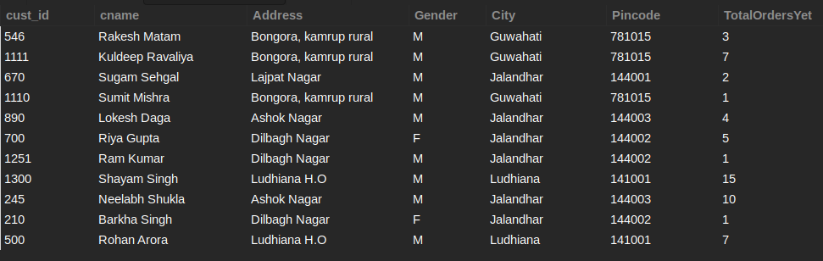

EMPLOYEE

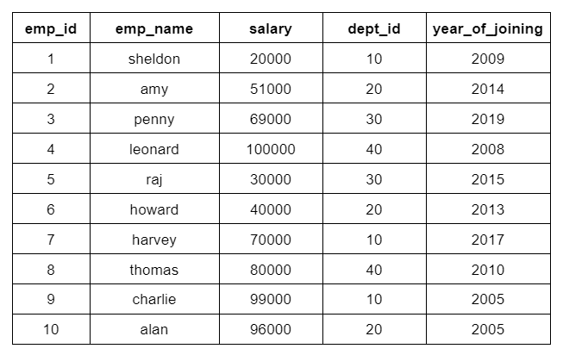

EMPLOYEE_DATA

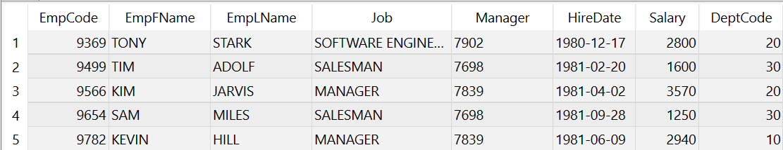

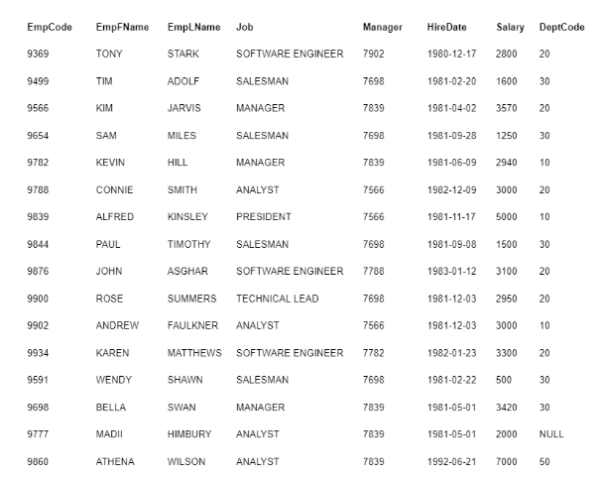

Q29: List out the unique values for the gender attribute using Group by clause.

SELECT GENDER FROM CUSTOMER GROUP BY GENDER;

SELECT DISTINCT GENDER FROM CUSTOMER;

+--------+

| GENDER |

+--------+

| M |

| F |

+--------+

Q30: Write an SQL query to find different years in which the employees join after the year 2010.

SELECT YEAR_OF_JOINING FROM EMPLOYEE WHERE YEAR_OF_JOINING > 2010 GROUP BY YEAR_OF_JOINING;

+-----------------+

| YEAR_OF_JOINING |

+-----------------+

| 2014 |

| 2019 |

| 2015 |

| 2013 |

| 2017 |

+-----------------+

Q31: Write an SQL query to get the list of all the department's ids present in the Employee table where salary is greater than 50000.

SELECT DEPT_ID FROM EMPLOYEE WHERE SALARY > 50000 GROUP BY DEPT_ID;

+---------+

| DEPT_ID |

+---------+

| 20 |

| 30 |

| 40 |

| 10 |

+---------+

Q32: List the number of customers from each city.

SELECT CITY, COUNT(CITY) AS CUST_NUM FROM CUSTOMER GROUP BY CITY;

+-----------+----------+

| CITY | CUST_NUM |

+-----------+----------+

| Guwahati | 3 |

| Jalandhar | 6 |

| Ludhiana | 2 |

+-----------+----------+

Q33: List out the total number of orders made to each address.

SELECT ADDRESS, SUM(TOTALORDERSYET) FROM CUSTOMER GROUP BY ADDRESS;

+-----------------------+---------------------+

| ADDRESS | SUM(TOTALORDERSYET) |

+-----------------------+---------------------+

| Bongora, kamrup rural | 11 |

| Lajpat Nagar | 2 |

| Ashok Nagar | 14 |

| Dilbagh Nagar | 7 |

| Ludhiana H.O | 22 |

+-----------------------+---------------------+

Q34: List out the maximum number of orders made from a particular Pincode.

SELECT PINCODE, MAX(TOTALORDERSYET) FROM CUSTOMER GROUP BY PINCODE;

+---------+---------------------+

| PINCODE | MAX(TOTALORDERSYET) |

+---------+---------------------+

| 781015 | 7 |

| 144001 | 2 |

| 144003 | 10 |

| 144002 | 5 |

| 141001 | 15 |

+---------+---------------------+

Q35: List out the minimum number of orders made from a particular Gender.

SELECT GENDER, MIN(TOTALORDERSYET) FROM CUSTOMER GROUP BY GENDER;

+--------+---------------------+

| GENDER | MIN(TOTALORDERSYET) |

+--------+---------------------+

| M | 1 |

| F | 1 |

+--------+---------------------+

Q36: List out the Average number of orders made from each City.

SELECT CITY, AVG(TOTALORDERSYET) FROM CUSTOMER GROUP BY CITY;

+-----------+---------------------+

| CITY | AVG(TOTALORDERSYET) |

+-----------+---------------------+

| Guwahati | 3.6667 |

| Jalandhar | 3.8333 |

| Ludhiana | 11.0000 |

+-----------+---------------------+

Q37: List the cities in descending order of the number of customers residing in them.

SELECT CITY, COUNT(CITY) AS NUMBER FROM CUSTOMER GROUP BY CITY ORDER BY NUMBER DESC;

+-----------+--------+

| CITY | NUMBER |

+-----------+--------+

| Jalandhar | 6 |

| Guwahati | 3 |

| Ludhiana | 2 |

+-----------+--------+

Q38: List down all the addresses from Jalandhar city with the number of times the address appears.

SELECT ADDRESS, COUNT(ADDRESS) AS ADDRESS_TIMES FROM CUSTOMER WHERE CITY="JALANDHAR" GROUP BY ADDRESS;

+---------------+---------------+

| ADDRESS | ADDRESS_TIMES |

+---------------+---------------+

| Lajpat Nagar | 1 |

| Ashok Nagar | 2 |

| Dilbagh Nagar | 3 |

+---------------+---------------+

Q39: Fetch the number of employees for each role/Job.

SELECT JOB, COUNT(JOB) AS EMPNUM FROM EMPLOYEE_DATA GROUP BY JOB;

+-------------------+--------+

| JOB | EMPNUM |

+-------------------+--------+

| SOFTWARE ENGINEER | 3 |

| SALESMAN | 4 |

| MANAGER | 3 |

| ANALYST | 5 |

| PRESIDENT | 1 |

| TECHNICAL LEAD | 1 |

+-------------------+--------+

Q40: List out the number of employees for each distinct role corresponding with their department code.

SELECT JOB, DEPTCODE, COUNT(*) AS NUMBER_OF_EMPLOYEES FROM EMPLOYEE_DATA GROUP BY JOB, DEPTCODE;

+-------------------+----------+---------------------+

| JOB | DEPTCODE | NUMBER_OF_EMPLOYEES |

+-------------------+----------+---------------------+

| SOFTWARE ENGINEER | 20 | 3 |

| SALESMAN | 30 | 4 |

| MANAGER | 20 | 1 |

| MANAGER | 10 | 1 |

| ANALYST | 20 | 1 |

| PRESIDENT | 10 | 1 |

| TECHNICAL LEAD | 20 | 1 |

| ANALYST | 10 | 1 |

| MANAGER | 30 | 1 |

| ANALYST | NULL | 1 |

| ANALYST | 50 | 2 |

+-------------------+----------+---------------------+

Q41: List down the maximum salaries for each Job role

SELECT JOB, MAX(SALARY) FROM EMPLOYEE_DATA GROUP BY JOB;

+-------------------+-------------+

| JOB | MAX(SALARY) |

+-------------------+-------------+

| SOFTWARE ENGINEER | 3300 |

| SALESMAN | 1600 |

| MANAGER | 3570 |

| ANALYST | 7000 |

| PRESIDENT | 5000 |

| TECHNICAL LEAD | 2950 |

+-------------------+-------------+

Q42: List down the average salary given out for each department for specific job roles.

SELECT JOB, DEPTCODE, AVG(SALARY) FROM EMPLOYEE_DATA GROUP BY JOB, DEPTCODE;

+-------------------+----------+-------------+

| JOB | DEPTCODE | AVG(SALARY) |

+-------------------+----------+-------------+

| SOFTWARE ENGINEER | 20 | 3066.6667 |

| SALESMAN | 30 | 1212.5000 |

| MANAGER | 20 | 3570.0000 |

| MANAGER | 10 | 2940.0000 |

| ANALYST | 20 | 3000.0000 |

| PRESIDENT | 10 | 5000.0000 |

| TECHNICAL LEAD | 20 | 2950.0000 |

| ANALYST | 10 | 3000.0000 |

| MANAGER | 30 | 3420.0000 |

| ANALYST | NULL | 2000.0000 |

| ANALYST | 50 | 6000.0000 |

+-------------------+----------+-------------+

Q43: List down the minimum salaries offered for each job role in each department, also list them in descending order based on the max salaries being offered for that role.

SELECT JOB, DEPTCODE, MIN(SALARY) FROM EMPLOYEE_DATA GROUP BY JOB, DEPTCODE ORDER BY MAX(SALARY) DESC;

+-------------------+----------+-------------+

| JOB | DEPTCODE | MIN(SALARY) |

+-------------------+----------+-------------+

| ANALYST | 50 | 5000 |

| PRESIDENT | 10 | 5000 |

| MANAGER | 20 | 3570 |

| MANAGER | 30 | 3420 |

| SOFTWARE ENGINEER | 20 | 2800 |

| ANALYST | 20 | 3000 |

| ANALYST | 10 | 3000 |

| TECHNICAL LEAD | 20 | 2950 |

| MANAGER | 10 | 2940 |

| ANALYST | NULL | 2000 |

| SALESMAN | 30 | 500 |

+-------------------+----------+-------------+

Q44: Write an SQL Query to count the distinct emp_id in each department in the Employee table.

Note: Name the number of distinct employees as "Emp_num" using the Alias Keyword.

SELECT DEPT_ID, COUNT(DEPT_ID) AS EMP_NUM FROM EMPLOYEE GROUP BY DEPT_ID;

+---------+---------+

| DEPT_ID | EMP_NUM |

+---------+---------+

| 10 | 3 |

| 20 | 3 |

| 30 | 2 |

| 40 | 2 |

+---------+---------+

Q45: List down the addresses with the city and the pincode which appear more than twice in the table.

SELECT ADDRESS, CITY, PINCODE FROM CUSTOMER GROUP BY ADDRESS, CITY, PINCODE HAVING COUNT(PINCODE) > 2;

+-----------------------+-----------+---------+

| ADDRESS | CITY | PINCODE |

+-----------------------+-----------+---------+

| Bongora, kamrup rural | Guwahati | 781015 |

| Dilbagh Nagar | Jalandhar | 144002 |

+-----------------------+-----------+---------+

Q46: List down all the addresses which belong to Guwahati and have made more than 7 orders in total.

SELECT ADDRESS FROM CUSTOMER WHERE CITY="GUWAHATI" GROUP BY ADDRESS HAVING SUM(TOTALORDERSYET) > 7;

+-----------------------+

| ADDRESS |

+-----------------------+

| Bongora, kamrup rural |

+-----------------------+

Q47: List down the jobs having an average salary more than 3000 USD.

SELECT JOB FROM EMPLOYEE_DATA GROUP BY JOB HAVING AVG(SALARY) > 3000;

+-------------------+

| JOB |

+-------------------+

| SOFTWARE ENGINEER |

| MANAGER |

| ANALYST |

| PRESIDENT |

+-------------------+

Q48: List down the department's codes that pay their employees (combined) more than 5000 USD and list them in ascending order of the minimum salary offered by each department.

SELECT DEPTCODE FROM EMPLOYEE_DATA GROUP BY DEPTCODE HAVING SUM(SALARY) > 5000 ORDER BY MIN(SALARY);

+----------+

| DEPTCODE |

+----------+

| 30 |

| 20 |

| 10 |

| 50 |

+----------+

Q49: List down the managers handling more than 2 employees, and make sure those employees don’t belong to departments 10 and 20.

SELECT MANAGER, COUNT(EMPCODE) AS 'NUMBER OF EMPLOYEES'

FROM EMPLOYEE_DATA

WHERE DEPTCODE NOT IN(10, 20)

GROUP BY MANAGER

HAVING COUNT(EMPCODE) > 2;

+---------+---------------------+

| MANAGER | NUMBER OF EMPLOYEES |

+---------+---------------------+

| 7698 | 4 |

| 7839 | 3 |

+---------+---------------------+

Q50: For All the Analyst jobs list down the maximum salaries offered to them in different departments and under different managers, list all the details in ascending order based on the combined salary given out by that department

SELECT JOB, DEPTCODE, MANAGER, MAX(SALARY) FROM EMPLOYEE_DATA

GROUP BY JOB, DEPTCODE, MANAGER

HAVING JOB = 'ANALYST'

ORDER BY SUM(SALARY);

+---------+----------+---------+-------------+

| JOB | DEPTCODE | MANAGER | MAX(SALARY) |

+---------+----------+---------+-------------+

| ANALYST | NULL | 7839 | 2000 |

| ANALYST | 20 | 7566 | 3000 |

| ANALYST | 10 | 7566 | 3000 |

| ANALYST | 50 | 7839 | 7000 |

+---------+----------+---------+-------------+